**Business Opportunities in Various Sectors and Venue Analysis in Toronto**

**Introduction**

Among various countries, Canada is still one of the top countries where various people move in order to achieve a higher stage in both personal and financial aspects. A survey according to <https://www.canadafranchiseopportunities.ca/low-cost-franchises> suggests that Canada has an amazing resource and opportunities to invest in.

Toronto, the capital of the province of Ontario, is a major Canadian city along Lake Ontario’s northwestern shore. It's a dynamic metropolis with a core of soaring skyscrapers, all dwarfed by the iconic, free-standing CN Tower. Toronto also has many green spaces, from the orderly oval of Queen’s Park to 400-acre High Park and its trails, sports facilities and zoo.

Although Canada is known for its wonderful job opportunities, a person who is moving to Canada, Toronto in particular, in order to excel must know various top industries that are excelling as to the current date based on the past records. My project will act as a extended helping hand for those who aspire to start a career in Toronto and will give a detailed report on what are the major preferences of people staying in Toronto.

**Data Description**

To consider the problem we can list the data as below. I found the Toronto neighborhood data, a Wikipedia page that has all the information to explore, segment, and cluster the neighborhoods in the city of Toronto. I had to scrape the Wikipedia page and wrangle the data, clean it, and then read it into a pandas dataframe so that it is in a structured format using beautiful soap library which I imported. The .json file has coordinates of the all city of Toronto. I cleaned the data.I used **Foursquare API** to get the most common venues of given Borough of Toronto. Using the explore function I explored various neighborhood in and around central, east, downward and northern toronto.

**Methdology**

As a database, I used GitHub repository in my study. My master data which has the main components *Borough, Average House Price, Latitude* and *Longitude* information of the city.

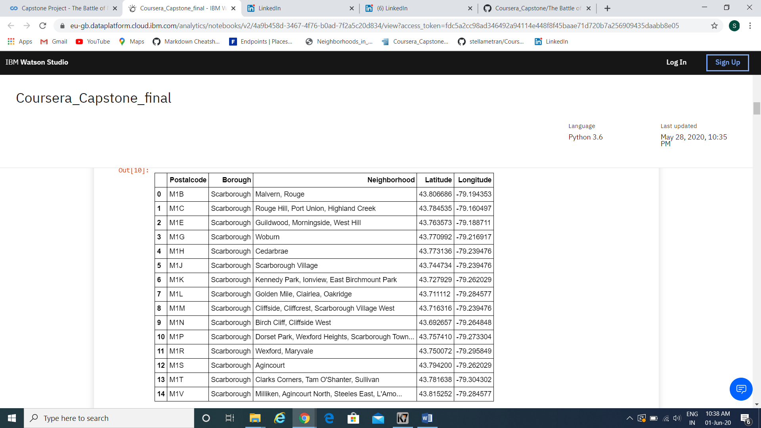

I used python **folium** library to visualize geographic details of Toronto and its boroughs and I created a map of Toronto with boroughs superimposed on top. I used latitude and longitude values to get the visual as below:

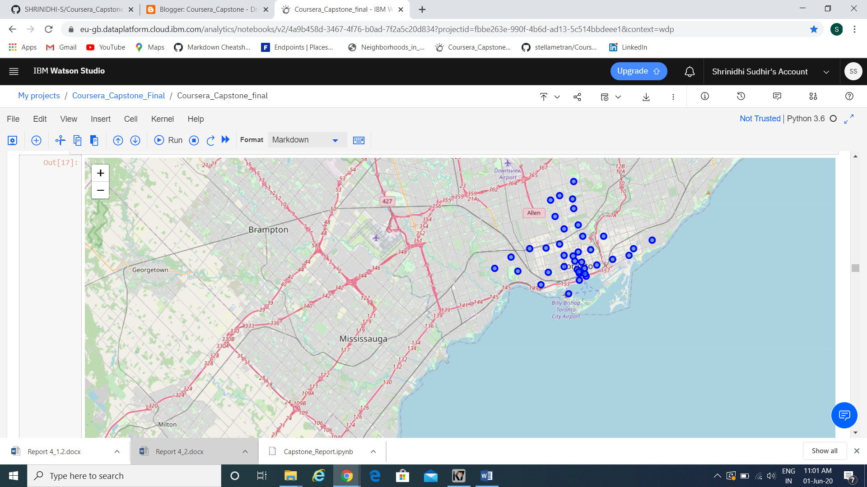

I utilized the Foursquare API to explore the boroughs and segment them. I designed the limit as **100 venues** and the radius **500 meter** for each borough from their given latitude and longitude information. Here is a head of the list Venues name, category, latitude and longitude information from Foursquare API.

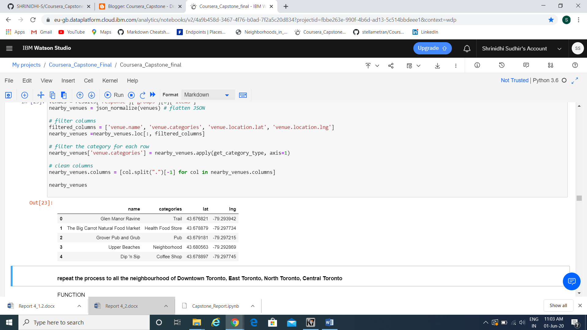

We can see that **Commerce Court;Victoria Hotel , First Canadian Place;Underground city, Garden District;Ryerson , Harbourfront East; Union Station;Toronto Islands** and **Toronto Dominion Centre;Design Exchange** have reached the **100** limit of venues. On the other hand; **The Beaches, Roselawn, Rosedale, Parkdale; Roncesvalles, Summerhill West; Rathnelly; South Hill; Forest Hill SE; Deer Park** , **North Toronto West; Lawrence Park**, **Moore Park; Summerhill East , Lawrence Park , Forest Hill North & West, Forest Hill Road Park , Dufferin, Dovercourt Village , Davisville North , Christie , CN Tower; King and Spadina; Railway Lands; Harbourfront West; Bathurst Quay; South Niagara; Island airport** and **Business reply mail Processing Centre; South Central Letter Processing Plant Toronto** boroughs are below **20** venues in our given coordinates with Latitude and Longitude, in below graph.

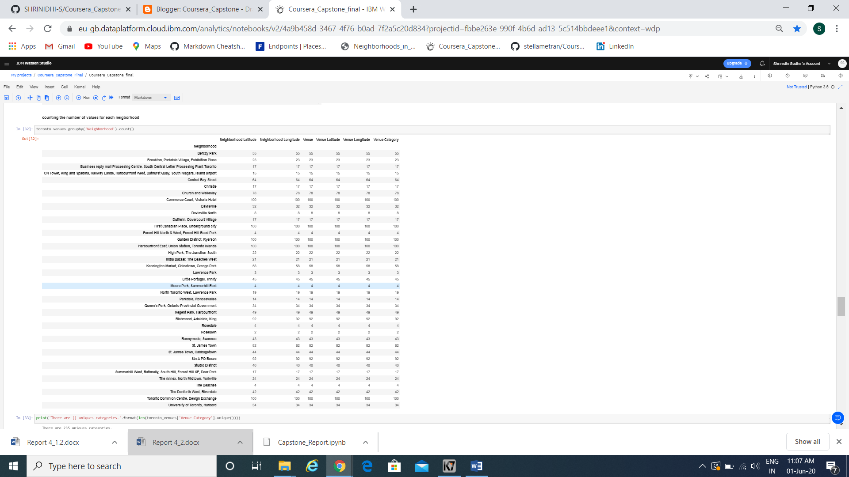

The result doesn’t mean that inquiry run all the possible results in boroughs. Actually, it depends on given Latitude and Longitude informations and here is we just run single Latitude and Longitude pair for each borough. We can increase the possibilities with Neighborhood informations with more Latitude and Longitude informations.

In summary of this graph 2**39** unique categories were returned by Foursquare, then I created a table which shows list of top 10 venue category for each borough in below table.

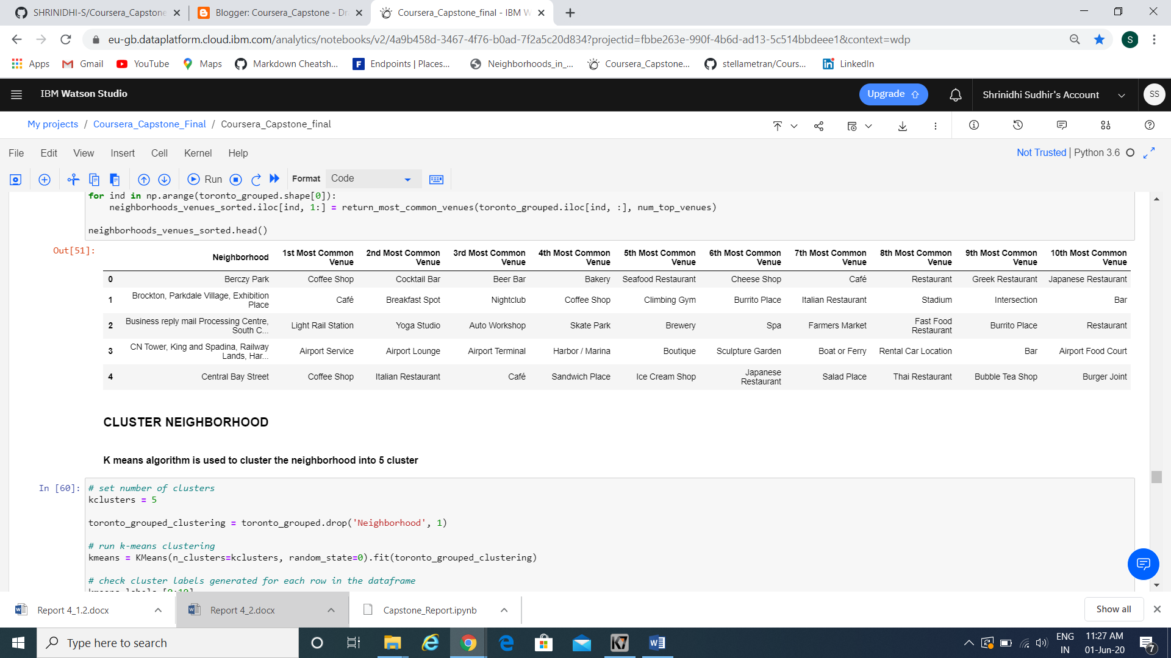

We have some common venue categories in boroughs. In this reason I used unsupervised learning **K-means algorithm** to cluster the boroughs. K-Means algorithm is one of the most common cluster method of unsupervised learning.

First, I will run K-Means to cluster the boroughs into **5** clusters because when I analyze the K-Means with elbow method it ensured me the 5 degree for optimum k of the K-Means.

Here is my merged table with cluster labels for each borough.

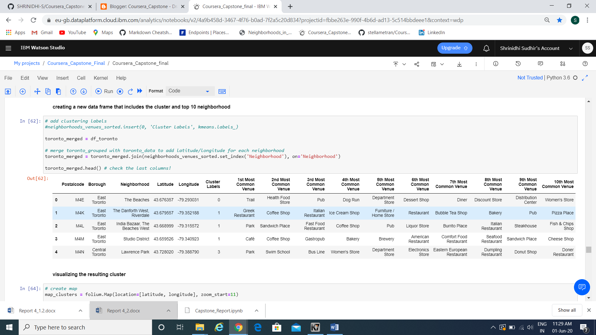

We can also estimate the number of **1st Most Common Venue** in each cluster.

When we examine :

* Cluster 0 : “Trial”
* Cluster 1 : “Cafe Venues”
* Cluster 3 : “Parks and playground”
* Cluster 4 : “ Parks and Swim Schools”
* Cluster 5 : “Garden”

From the results it is well evident that four out of five cluster provide information that the people living in those areas are more fond of food and entertainment. The above results shows the evident result that a amusement parks with the food can be a good initiative to start a business in that location.

**C. Results**

Let’s merge those new variables with related cluster informations in our main **master table**.



You can now see Join, Labels and Level_labels columns as the last three ones in above table. You can also see a clustered map boroughs of Toronto in the below.

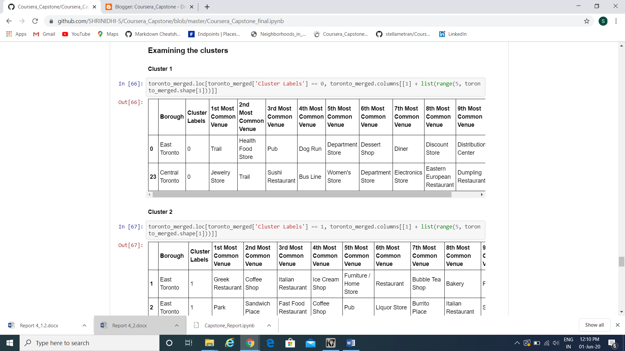

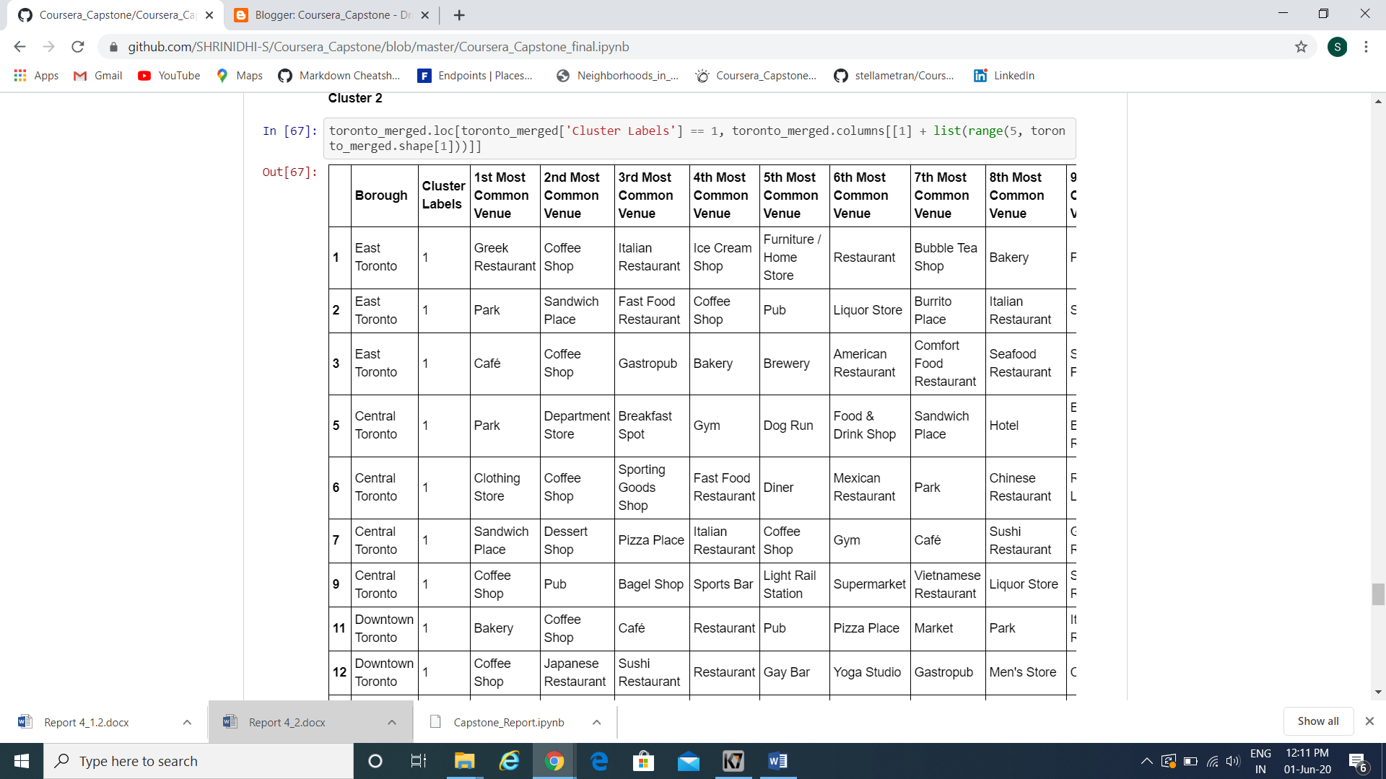

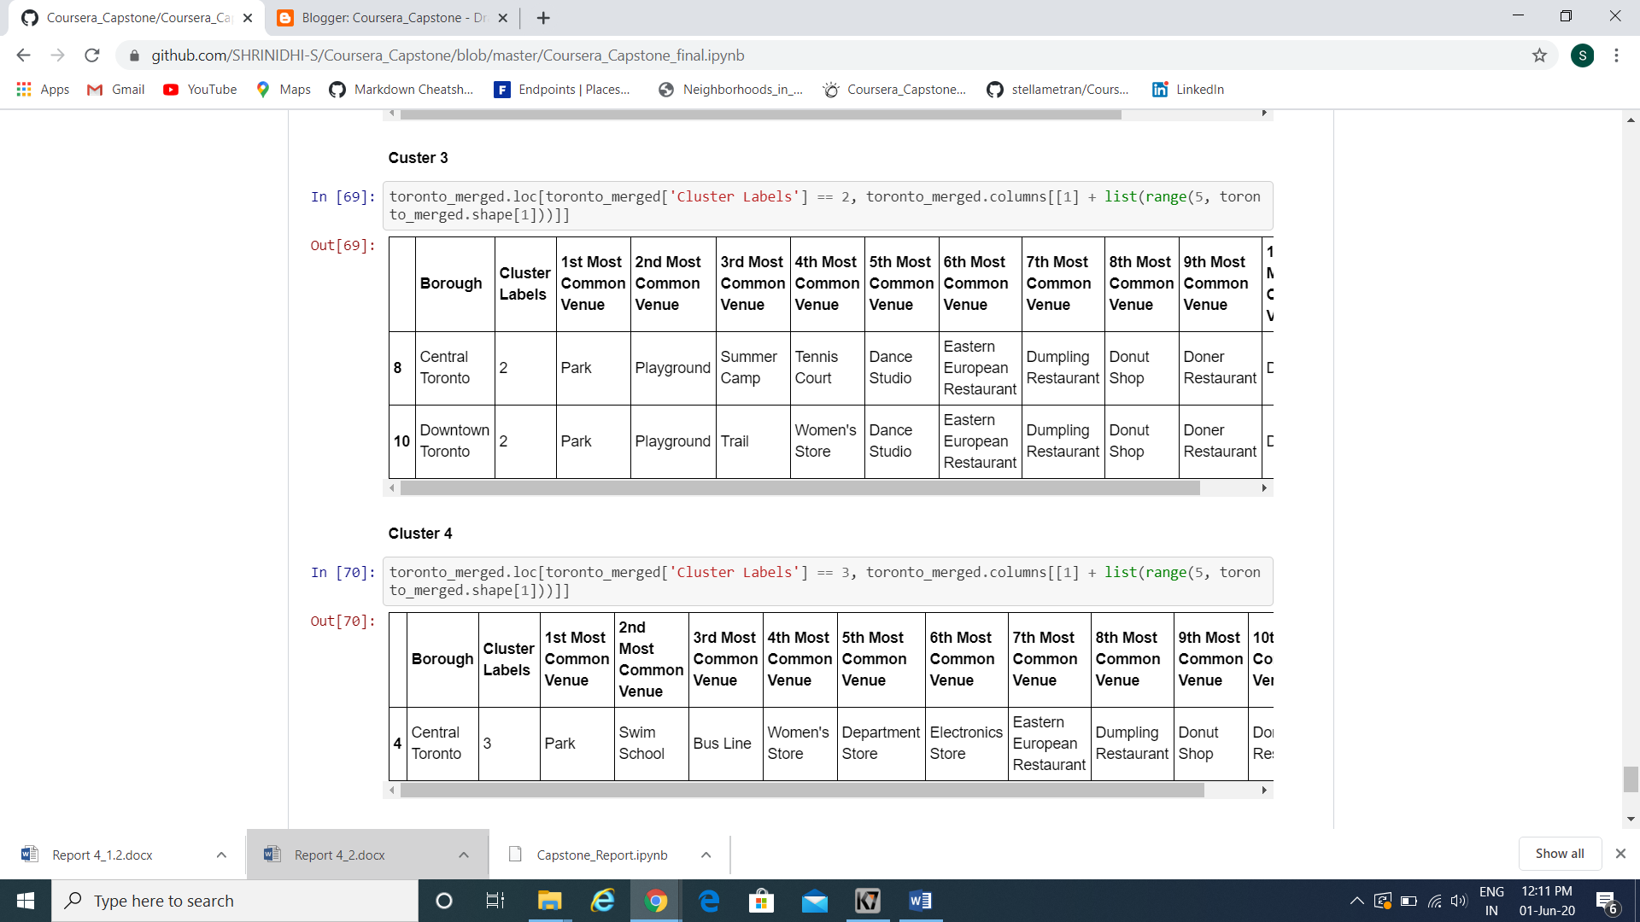

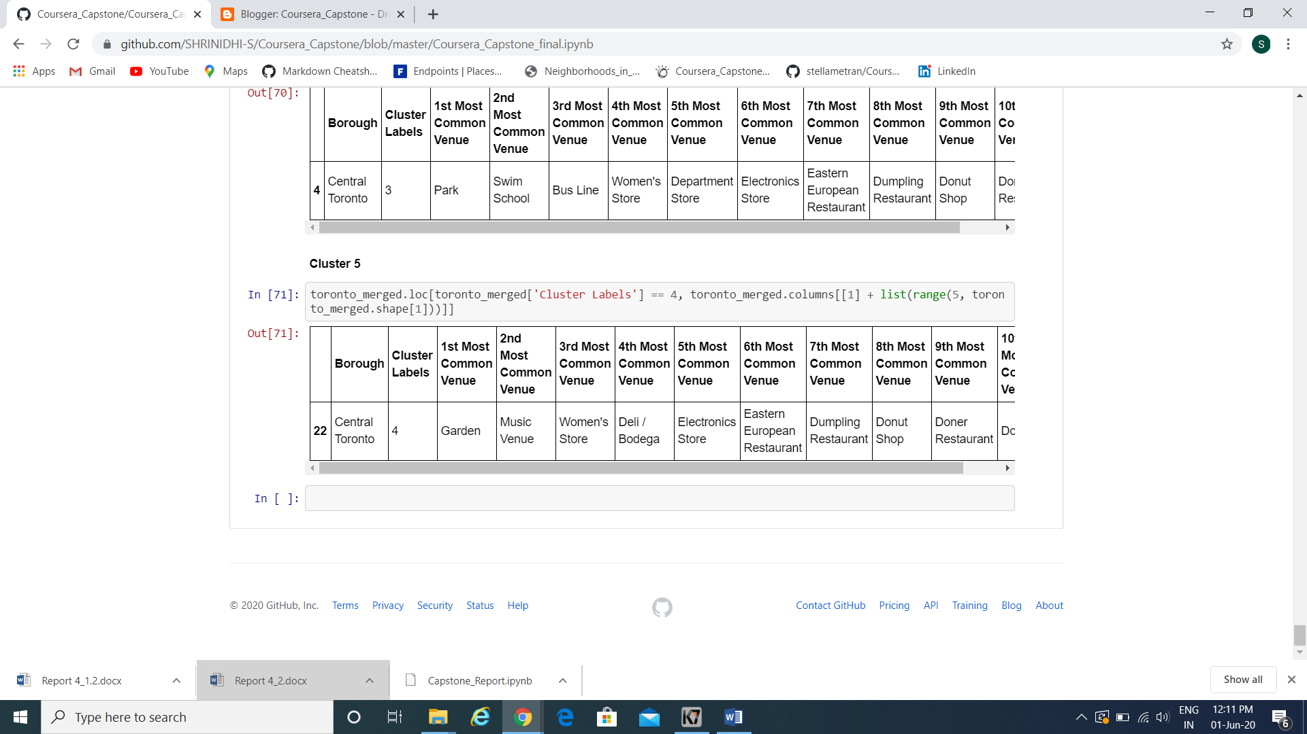   
Comparing the maps we can notice the majority of the restaurants grouped on main streets and on the south of the city, although some of the wealthiest neighborhoods are up to the north. Also, the areas with a dense population don't reflect on the number of restaurants. From the results it is well evident that four out of five cluster provide information that the people living in those areas are more fond of food and entertainment. The above results shows the evident result that a amusement parks with the food can be a good initiative to start a business in that location.

**Discussions**

A business is defined as an organization or enterprising entity engaged in commercial, industrial, or professional activities. Businesses can be for-profit entities or non-profit organizations that operate to fulfill a charitable mission or further a social cause.

Amusement, or theme, parks feature rides, games, and entertainment options in an outdoor or indoor venue. Customers typically pay a single entry fee for access to the entire park. The successful amusement park model focuses on the customer's entire experience, offering a wide range of services and entertainment options including parking, trams, restaurant options, water parks, roller coasters, live animal attractions, stage shows, arcade games, attractive interactive landscaping, and family friendly fun. The larger the property you own, the more entertainment choices you are able to offer your customers.

Since most of the results shows that people prefer fun activity in that particular area, a proper amusement parks in that area will result in great profit.

Few prominent problem include , The area availability ( As it is also a place where people live allocating a particular area for these parks is a major issue)

**Disadvantages:**

## Expense:

Most theme parks are priced at well over $20 per person, per day. This can add up quickly for families, especially those who wish to spend more than one day exploring a park. In addition to entrance fees, many parks charge additional fees for individual rides and events. And food booths at amusement parks tend to be exorbitantly priced. Feeding a family can easily cost more than $10 per person for a single meal. Add on hotel expenses and flight or gas prices and you have a considerable expense for a family outing.

## Unnatural Setting:

A theme park is comprised of man-made rides and attractions. For this reason, amusement parks do not offer much in the way of natural beauty or rustic charm. While a national park provides numerous environmental learning opportunities, theme parks are primarily geared toward titillating an individual's senses. Rides, shows and attractions create numerous passive entertainment opportunities, which do not require much physical or mental effort on the part of family members.

## Wait Time:

If you plan a trip to an amusement park during the peak summer season, you can expect to wait in line for each ride anywhere from a half hour to three hours. It can be difficult to keep younger children on good behavior while they are packed like sardines in a slow-moving queue. Wait times for rides are significantly shorter during off-peak seasons, but environmental factors like rain and cold weather need to be considered when deciding which month is best for your vacation.

## Ride Prerequisites:

Many amusement park rides have signs that read, "You must be this tall to ride this ride." This means that if you are bringing small children with you to the amusement park, they will not be able to enjoy many of the roller coasters or other "big kid" rides. Parents may need to split up in order to entertain children while the rest of the family gets a thrill ride on a coaster or other ride. This can diminish the number of overall family bonding opportunities during your vacation and make younger kids feel left out.

### Conclusion

As a result, people are turning to big cities to start a business or work. For this reason, people can achieve better outcomes through their access to the platforms where such information is provided. I hope my understanding of the data and my project based on this issue can help many upcoming business men and entrepreneurs.

Not only for investors but also city managers can manage the city more regularly by using similar data analysis types or platforms.

**References**

<https://www.linkedin.com/pulse/housing-sales-prices-venues-data-analysis-ofistanbul-sercan-y%C4%B1ld%C4%B1z/>

<https://getawaytips.azcentral.com/the-disadvantages-of-an-amusement-park-12565522.html>

<https://www.canadafranchiseopportunities.ca/low-cost-franchises/>